Kiwi Bubbles Model Development

The Kiwi Bubbles dataset contains the number of adopters (out of a panel of 1499) who tried a new CPG product each week during the test market. The purpose of this exercise is to develop a forecasting model. Using the first 26 weeks of data, the intent is to build a forecasting model so that we can predict the number of triers between weeks 27-52.

For the geometric, linear trend, and quadratic trend models, we will follow the same general approach:

1. **Calculate P(Not yet tried) in Column D**. This can be calculated by multiplying the previous period’s P(Not yet tried) by the probability of not trying the product in the current period. Cell D6=1 because no customers may try the product at the start of the observation period. Cell D7=D6*(1-p), where p is the probability of trying the product. Under the geometric model, this is a single value. For the linear and quadratic trend models, the probability p is a function of the week number (Column A).
2. **Calculate P(try in this week) in Column E**. This is given by the difference between the probability of having not yet tried the product previously, and the probability of having not tried the product after this week. For example, E6=D6-D7.
3. **Calculate the log-likelihood in Column F**. For the cases in which we observe the number of incremental triers (F6:F31), this is given by multiplying the number of incremental triers (Column C) by ln(probability of trial in the current week). In F32, we calculate the likelihood associated with those customers who have not yet tried the product. For these 1398 (1499-101 triers through week 26), the probability of not yet having tried the product is given in cell D32 (probability of not yet having tried the product by week 27).
4. **Calculate the predicted incremental adopters in Column G**. This can be derived by multiplying the total sample size (B2) by the probability of trying a product in a given week (Column E).
5. **Calculate the predicted cumulative adopters in Column H**. This is a running total of the number of predicted incremental adopters. We begin by specifying H6=G6. Subsequently, H7=H6+G7, H8=H7+G8, and so on.

A note in estimating models in Excel. If you run Solver and receive an error message, on potential cause is numerical underflow. This can result because we are taking the logarithm of probabilities. If the probability cannot be distinguished from 0, this will produce an error message. One way to work around this is to ensure that the estimated coefficients do not take on values that are large in magnitude, which often contributes to underflow. To do so, you may impose constraints on values in Solver.

For the linear time trend, the model was successfully estimated using the following constraints:

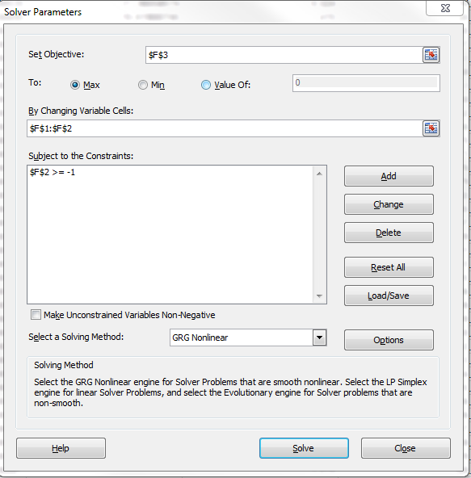

For the quadratic time trend model, the following constraints were used:

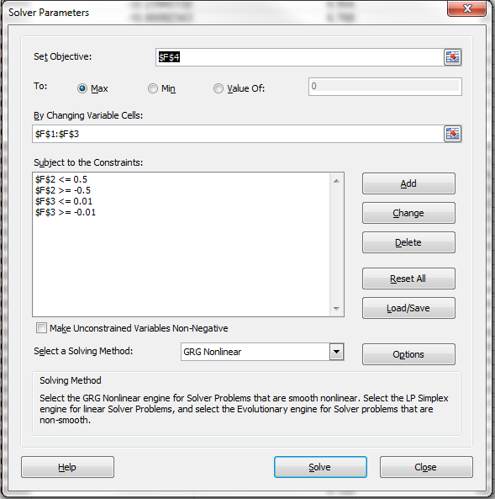

Bringing in the Hardcore Never Buyer (HCNB) Segment

To estimate the models with the HCNB segment, we generally follow the same setup as before, but we need to incorporate the probability of being a HCNB. We will do this in the column where we calculate the weekly probability of trial. The general setup is as follow:

1. **Calculate P(Not yet tried) in Column D**. This can be calculated by multiplying the previous period’s P(Not yet tried) by the probability of not trying the product in the current period. Cell D8=1 because no customers may try the product at the start of the observation period. Cell D9=D8*(1-p), where p is the probability of trying the product. Under the geometric model, this is a single value. For the linear trend model, the probability p is a function of the week number (Column A). This is the probability of not yet having tried, assuming someone will eventually try the product. In the next step, we account for the HCNB probability.
2. **Calculate P(try in this week) in Column E**. This consists of two components. First, we look at the difference between the probability of having not yet tried the product previously, and the probability of having not tried the product after this week. For example, E8=D8-D9. Second, in order to try the product in a given week, a customer must not be in the HCNB segment, which occurs with a probability of 1-q. We take the product of these two terms to get P(try in this week).
3. **Calculate the log-likelihood in Column F**. For the cases in which we observe the number of incremental triers (F8:F33), this is given by multiplying the number of incremental triers (Column C) by ln(probability of trial in the current week). In F34, we calculate the likelihood associated with those customers who have not yet tried the product. For these 1398 (1499-101 triers through week 26), we must account for two possibilities. First, it may be that the customer is in the HCNB segment, with probability q. Second, it may be that they are not in the HCNB segment (with probability 1-q), and they have not yet tried the product (with probability given in cell D34). The resulting expression for the likelihood is: =(B2-B33)*LN($F$2+(1-$F$2)*D34)
4. **Calculate the predicted incremental adopters in Column G**. This can be derived by multiplying the total sample size (B2) by the probability of trying a product in a given week (Column E).
5. **Calculate the predicted cumulative adopters in Column H**. This is a running total of the number of predicted incremental adopters. We begin by specifying H8=G8. Subsequently, H9=H8+G9, H10=H9+G10, and so on.